CS 340 README Project 2

Use this template to complete your README file. When completing the template, keep the headings as they are so that your document has a clear organization. Remove the italicized prompt text after you have completed each section for a polished final document.

About the Project/Project Title
This application provides users with access to the CS 340 Austin Animal Center (AAC) database, enabling them to search and filter animal records efficiently. Users have the option to apply filters to find animals linked to Grazioso Salvare, the project’s requester, which results in the creation of a dashboard. Additionally, the project features geolocation mapping, interactive user interfaces, and data visualization through charts to assist in locating and utilizing animals for search and rescue operations.

Motivation
This program was created to assess my skills in database management and data manipulation. Python was selected as the main programming language for working with MongoDB because of its ease of use, flexibility, and strong compatibility with the database. Additionally, Python supports quick compilation through its built-in compiler when using Jupyter Notebook.

Getting Started
1. Access MongoDB and import the CSV file aac_shelter_outcome.csv.
2. Create both a simple and a complex index to efficiently parse the stored data.
3. To authenticate a user, establish an Admin account and an aacuser account for database access.
4. Ensure Python is installed and execute the program from a Jupyter Notebook.
5. Finally, enter the dashboard address and establish a connection.

Installation
- Python and Jupyter Notebook to run .py and .ipynb files
- Import PyMongo, Dash, Plotly and Leaflet libraries
- Access to MongoDB to access database

Usage
Use this space to show useful examples of how your project works and how it can be used. Be sure to include examples of your code, tests, and screenshots.

Code Example
Show what the library does as concisely as possible. Developers should be able to figure out how your project solves their problem by looking at the code example. Make sure that your code is short and concise.

Screenshots

Running Dash:
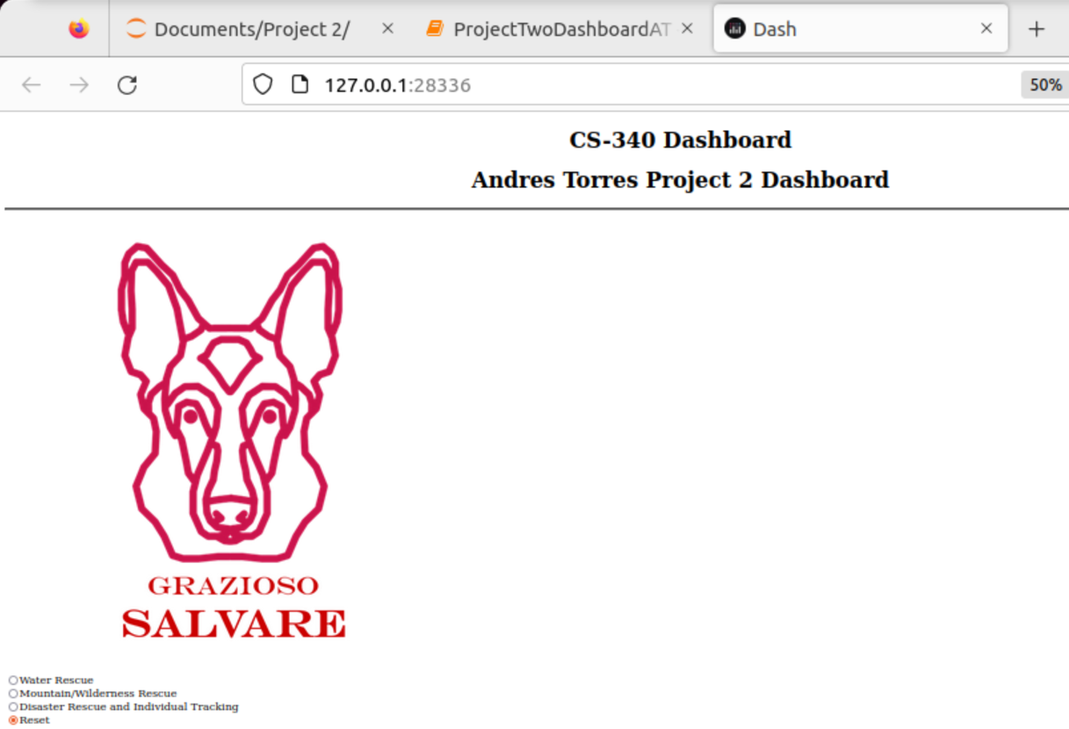

Working Radio Buttons:
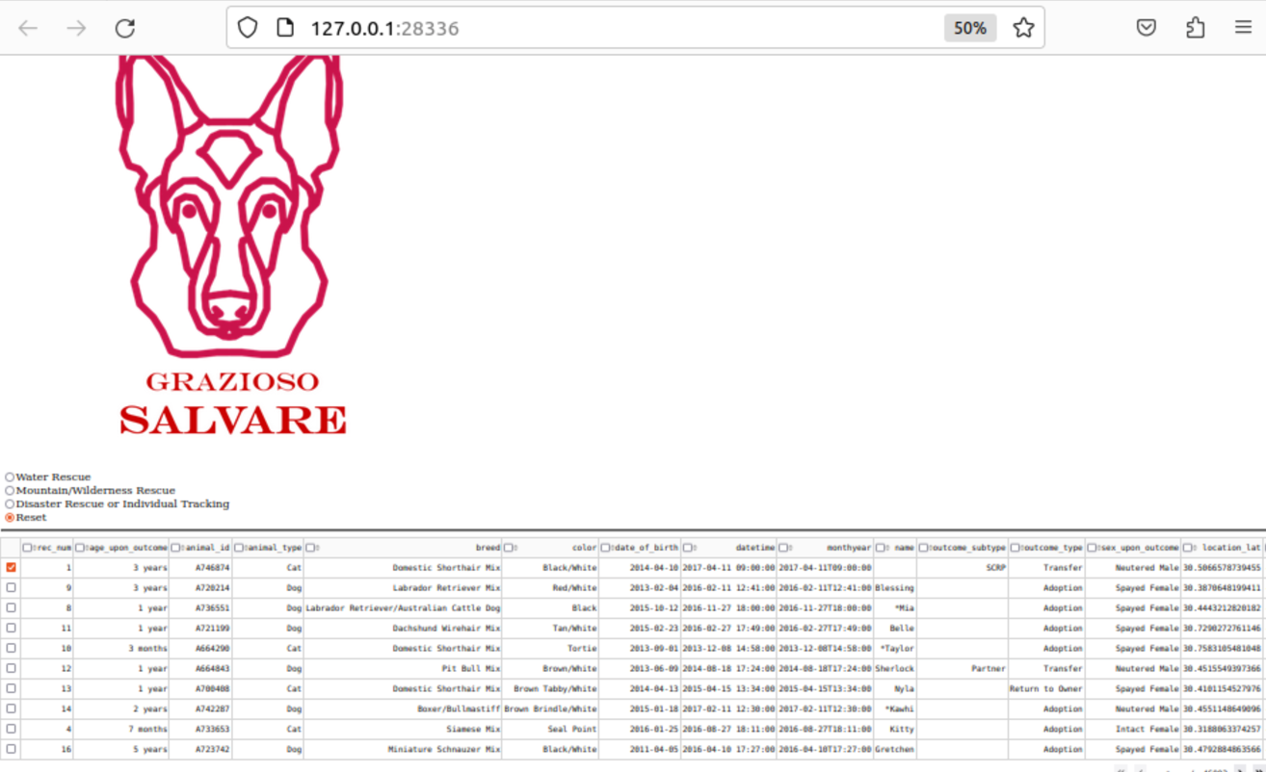

Sorting and Updating Geolocation:
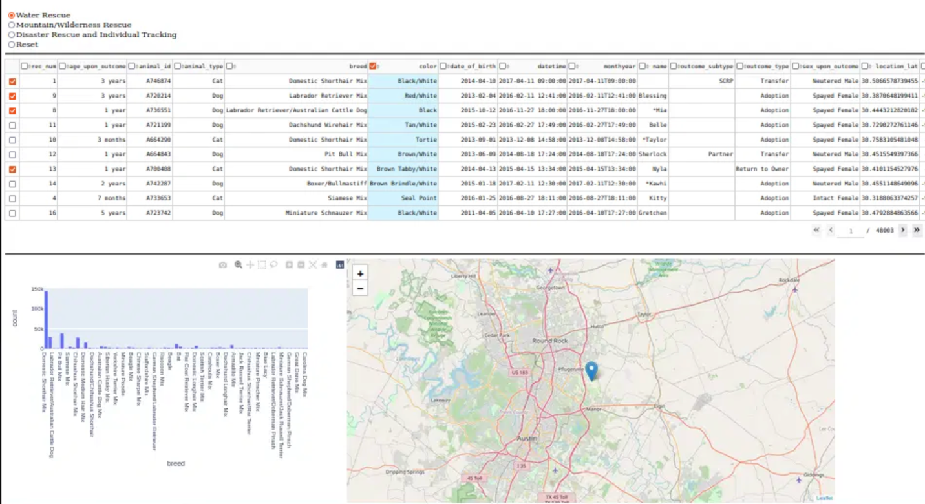

Contact
Your name: Andres Torres

